Experiment-9
Write A Python Program To Implement Travelling Salesman Problem
Aim
To write and execute a Python program to solve the Travelling Salesman Problem (TSP) using the brute-force method to find the shortest possible route that visits every city exactly once and returns to the starting city.
Algorithm
- Start the program.
- Define the distance matrix representing the distances between cities.
- Identify the total number of cities.
- Select the first city as the starting city.
- Generate all possible permutations of the remaining cities.
- Add the starting city at the beginning and end of each route.
- Calculate the total distance of each route.
- Compare the total distance with the minimum distance found so far.
- Update the minimum distance if a shorter route is found.
- Store the route corresponding to the minimum distance.
- Display the best route and its minimum distance.
- Stop the program.

Code
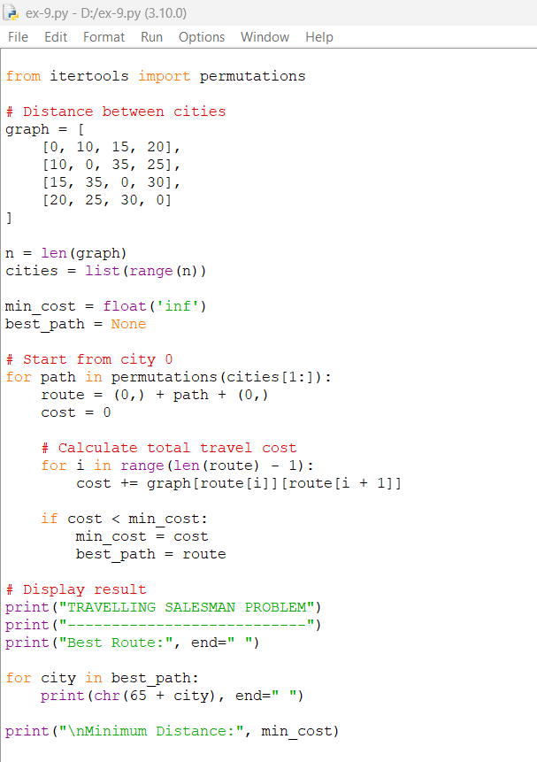
Output
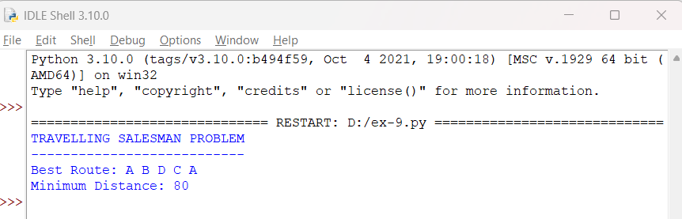
Result
The Travelling Salesman Problem was successfully implemented using Python 3.10. The program identifies the shortest route as A → B → D → C → A, with a minimum total distance of 80 units.

